Score: _____

WA5 – Back-End: Databases
Activities

COMP256 – Computing Abstractions
Dickinson College
Spring 2023
Prof. Grant Braught

Name:

Introduction:

Today’s class focused on the use of databases as a back-end resource in web applications and the SQL language for interacting with relational databases. Most back-end processing in a web application will make use of a database. When a request is received the query string or the API endpoint itself will tell the server what is being requested. The back-end code (a page generator, a server page or an API end point) will access the database and incorporate the information requested into the page or response. Of course, it is also possible for requests to update the contents of the database, but we will not address that today.

It is not required viewing, but if you would like another short take on databases and SQL the video What is SQL by Danielle Thé of Glitch gives a good short overview.
- https://www.youtube.com/watch?v=27axs9dO7AE (4:25)

Databases:

🔑 1. Briefly describe in a sentence of your own words the role that a database plays in a web application.

🔑 2. Give the term that would fill in the blanks in the following sentences about relational databases:

 | Sentence |  | Term
 | A table typically represents a thing which is called an _________.
 | The rows in a table are called __________.
 | A column is called an ___________.
 | A ________ has a unique value for each record in a table.
 | A ____________ is the name for a connection between tables.

Understanding Relations:

Relations or relationships are the ways that entities are related to each other. For example, in class we saw a customer and order database for a restaurant supply company. The entities were the customers, orders, employees and shippers. The relations between these entities expressed things like which orders were placed by which customers, or which employee processed an order or which company shipped an order.

Below are some small sub-sets of the tables that are in the sample database from class and that you will use for the rest of this set of activities. In this section you will use these tables to answer some questions manually about the data using the entities and relationships. In the next section you will write and test SQL to answer similar questions using the full database.

Table: Customers
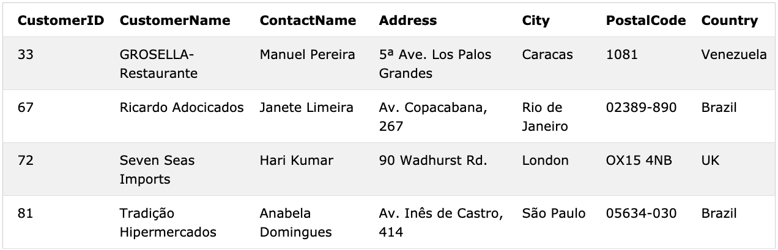
CompanyName
TRADH
RICAR
SEVES
GROSR
Table: Orders Table: Employees
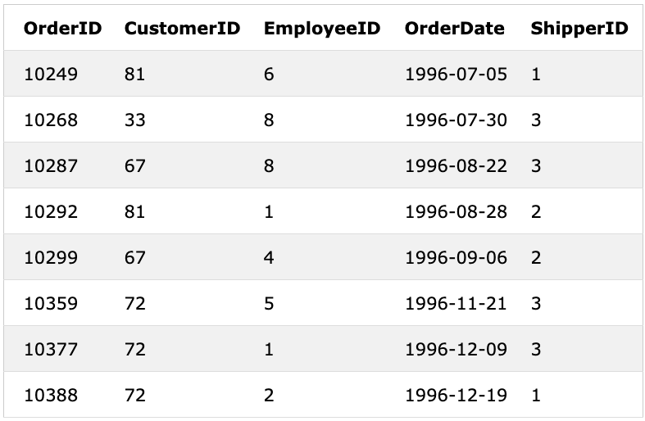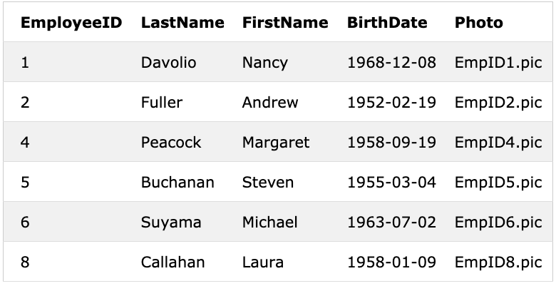
PhotoPath
ShipVia
SEVES
SEVES
SEVES
RICAR
TRADH
RICAR
GROSR
TRADH

Table: Shippers
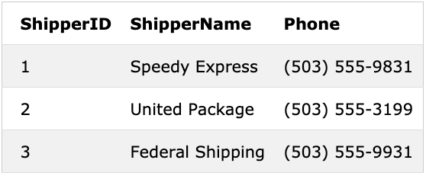
CompanyName

🔑 3. Use the above tables to answer the following questions:

a. What are the names of the companies that are customers in Brazil?

b. On what dates were orders placed from the UK?

c. What are the names of the employees who shipped orders in July 1996?

d. What are the names of the shipping companies that delivered orders to Venezuela?

e. What are the names of the employees that handled orders for Seven Seas Imports?

4. Think about how you answered parts b-e above. Then in a few sentences of your own words, briefly explain how keys are used to represent relations in a relational database.

Structured Query Language:

Structured Query Language or SQL is designed to answer exactly the types of questions about structured data that you answered above in question #3. In this section you will write and test some SQL statements that ask questions of the sample database.

You can write and test these statements by running them with the sample database in our Comp256Web container. To do so you will need to connect to the database:
- Ensure that the container is running and connect to it with Tiger VNC.
- Open a Terminal window and use the command:

sqlite3 /db/Northwind.db

After using the above command, you should see the prompt sqlite> where you can enter and run SQL statements as demonstrated in class.

🔑 5. Write and test SQL statements that will answer each of the following questions. Be sure to test your statements using the sample database. Give both the SQL statement and its output as the answer for each question.

a. Find the company name, contact name and address for all customers in Spain.

b. Find the order id and customer id for all orders placed on August 1st 2012.

6. In addition to simple equalities, the WHERE clause of an SQL statement can use relational operators. Review the page W3Schools page describing the WHERE clause to learn about the relational operators that can be used:
- https://www.w3schools.com/sql/sql_where.asp

Then give SQL statements that will answer each of the following questions. Be sure to test your statements using the sample database.

a. Find the first and last name of all employees born before January 1, 1970.

b. Find a list of the names of all customers that are not in the USA.

🏆 c. Find the dates of all orders handled by the employees with the ids 2, 4, and 8. Hint: Look at the example for the IN operator.

🏆 🏆 d. Optional: Find the Customer ids and dates for all orders placed before July 10th 2012 or after May 4th 2014. Hint: Look into the SQL logical operators (AND, OR, NOT):
  - https://www.w3schools.com/sql/sql_and_or.asp

🏆 🏆 e. Optional: Research the LIKE operator and give an SQL statement that lists all orders placed in December 2013.

JOIN Operations:

In order to answer some questions using a relational database it is necessary to bring together information from multiple tables. In SQL the JOIN operation allows us to combine multiple tables. The questions in this section deal with questions that require JOIN operations in order to answer.

🔑 7. Imagine we want to know all of the dates on which an employee with the last name Leverling processed orders.

a. What is the name of the table and attribute that contains the last names of the employees?

b. What is the name of the table and attribute that contains the dates on which orders occurred?

c. What is the name of the (key) attribute that creates the relation between an employee and the orders that they processed?

d. Give an SQL statement that lists of all of the dates on which the employee Leverling processed orders. Hint: You will want to SELECT the order dates FROM the result of JOINing the tables you identified in part a and b ON the attribute you identified in part c WHERE the employee’s last name is Leverling.

8. Give an SQL statement that uses a JOIN operation to answer each of the following questions.

a. Find the name and address of the customer that placed the order with id 10293.

b. Find the dates of all orders that were placed by customers in Venezuela.

🏆🏆 c. Optional: Find the first and last name of all of the employees that packed orders that were shipped to “Seven Seas Imports”. Hint: You’ll need to research how to JOIN multiple tables.

🏆 9. Optional: SQL statements can also be used to modify the information in the database. For example, the INSERT INTO, DELETE, and UPDATE and statements allow records to be added to or removed from or modified in the database. Use the resources given below to give SQL statements that accomplish each of the following tasks. Be sure to test your statements using the sample database.

a. Add a new shipping company to the database. Make up a name and phone number for the company. Hint: Check the W3Schools resources on the INSERT INTO statement:
  - https://www.w3schools.com/sql/sql_insert.asp

b. Delete all of the orders that were placed by “Tortuga Restaurante”. Hint: Check the W3Schools resources on the DELETE statement:
  - https://www.w3schools.com/sql/sql_delete.asp

c. Modify the contact for the customer “Around the Horn” to be “Alfie Solomons”. Hint: Check the W3Schools resources on the UPDATE statement:
  - https://www.w3schools.com/sql/sql_update.asp

Optional: To help me improve and scope these activities for future semesters please consider providing the following feedback.

a. Approximately how much time did you spend on this activity outside of class time?

b. Please comment on any particular challenges you faced in completing this activity.

